TV / COMPUTER CART
Streaming Station, Sanctuary Lobby
TURNING ON
1 | Turn on the computer.  Green button just left of the USB port on the front of the PC.

2 | Turn on the TV.  Remote power button, or the top button on the TV itself.

3 | Log in.  Touch the keyboard or mouse to wake the screen. Ask this week’s Hospitality team tech volunteer for the PIN if you don’t have it.

4 | Open Zoom Workplace and start/join the meeting.  Already logged into the church account, so no separate sign-in needed.

VERIFY THESE ARE SET (should stay set once configured)
Camera | Logi Rally Bar Mini
Microphone | iRig Pro
Speaker | Rally Bar Mini

HEARING ECHO OR FEEDBACK ON THE STREAM?
• "Original sound for musicians" should be ON
• "Echo cancellation" should be OFF
• "Automatically adjust microphone volume" should be OFF
• Zoom updates sometimes silently reset these. Check here first if the stream sounds off.

TALKING TO PEOPLE ON ZOOM
• Small mic on the cart. Press and HOLD the center button to talk.
• Light comes on while you're holding it. Let go and it turns off automatically.

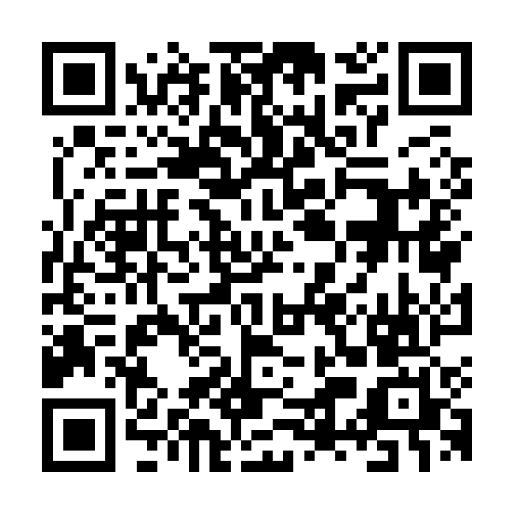 Scan for the full guide + troubleshooting

